SESSION 1.3: SP Page Builder Parser Foundation

Objectives:
- Create SP Page Builder JSON parsing system
- Extract text from SP content (text_block and heading addons)
- Create SP search engine class
- Integrate SP search with existing system
- Test with actual SP Page Builder content

Files to be Created:

File 1: SP Page Builder Parser
Location: /src/Parser/SPParser.php

File 2: SP Page Builder Search Engine
Location: /src/Search/SPSearch.php

File 3: Integrated Search Engine
Location: /src/Search/IntegratedSearch.php

File 4: Updated Search Model
Location: /src/Models/SearchModel.php (Update existing file)
We need to update the existing SearchModel to include SP Page Builder support. Replace the entire file with:

File 5: Updated AJAX Endpoint
Location: /src/Component/ajax.php (Update existing file)
Update the existing AJAX endpoint to use the integrated search:

File 6: Test Script for Session 1.3
Location: /test_sp_search.php (Temporary test file)

INSTALLATION INSTRUCTIONS

Step 1: Create New Directories
Create these directories in /components/com_ajaxsearch/src/:
/components/com_ajaxsearch/src/
├── Parser/ (new)

Step 2: Save New Files
Save the new files:
- SPParser.php → /components/com_ajaxsearch/src/Parser/SPParser.php
- SPSearch.php → /components/com_ajaxsearch/src/Search/SPSearch.php
- IntegratedSearch.php → /components/com_ajaxsearch/src/Search/IntegratedSearch.php

Step 3: Update Existing Files
Update these existing files (replace completely):
- SearchModel.php → /components/com_ajaxsearch/src/Models/SearchModel.php
- ajax.php → /components/com_ajaxsearch/src/Component/ajax.php

Step 4: Create Test File
Save the test script as /test_sp_search.php in your Joomla root.
Deepseek wrote new simpler test

https://phpstack-1208205-5933111.cloudwaysapps.com/test_minimal_sp.php

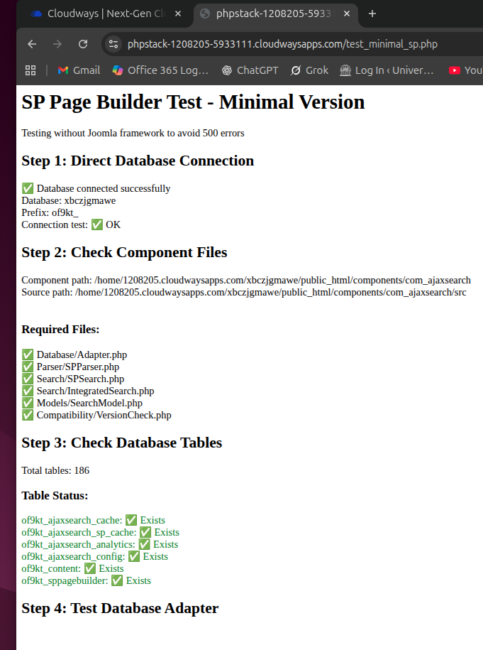
then Deepseek wrote a revised test: test_version_fixed.php
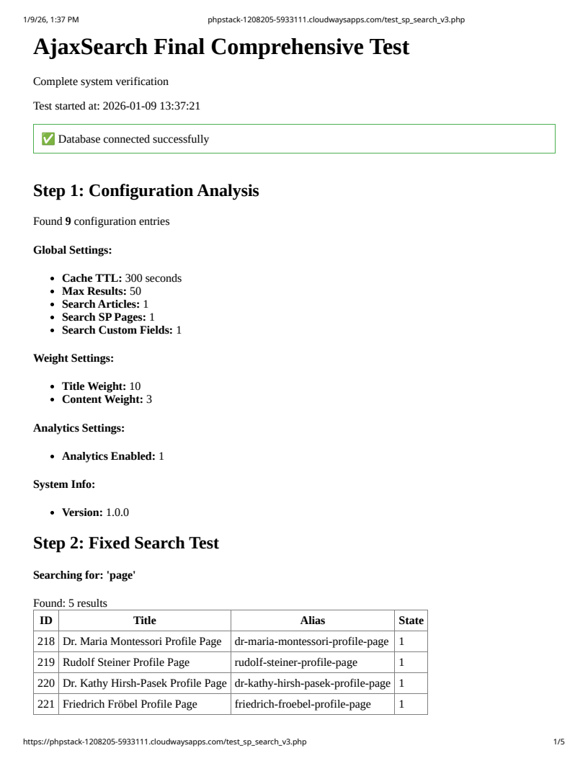

Step 5: Run Tests
- Access yoursite.com/test_sp_search.php in your browser
- Verify:
  - All new files are found (✓ marks)
  - SP Page Builder table detection works
  - Parser extracts text from JSON
  - Integrated search returns both article and SP results
  - No PHP errors

Step 6: Test AJAX Endpoints
Test these URLs:
- All content: ajax.php?q=test&limit=3
- Articles only: ajax.php?q=test&limit=3&type=article
- SP pages only: ajax.php?q=test&limit=3&type=sp
- With debug: ajax.php?q=test&limit=3&debug=1

Step 7: Clean Up
- Delete /test_sp_search.php after testing
- Verify all files are in correct locations

TESTING CRITERIA FOR THIS SESSION
✅ SP Parser:
- Extracts text from JSON structure
- Handles text_block and heading addons
- Caches parsed content
- Fallback parsing for unknown addons
✅ SP Search Engine:
- Searches SP Page Builder pages
- Respects published status and access levels
- Integrates with existing caching system
- Returns proper URLs for SP pages
✅ Integrated Search:
- Combines article and SP results
- Sorts by relevance across content types
- Allows type-specific searches
- Maintains backward compatibility
✅ Updated AJAX Endpoint:
- Supports type parameter
- Includes debug information
- Proper error handling
✅ Integration:
- All classes work together
- Cache system works for both types
- No PHP errors or warnings

TROUBLESHOOTING
SP Page Builder table not found:
- Verify SP Page Builder is installed
- Check table prefix is correct
- The system will still work for articles only
Parser errors:
- Check JSON structure of SP content
- Verify parser can handle your SP version
- Test with sample JSON first
No SP results in search:
- Check SP pages are published
- Verify content contains search terms
- Check access levels
Performance issues:
- SP parsing is cached automatically
- First parse may be slow, subsequent are fast
- Check cache tables are being used

